Build the Main Circuit Board

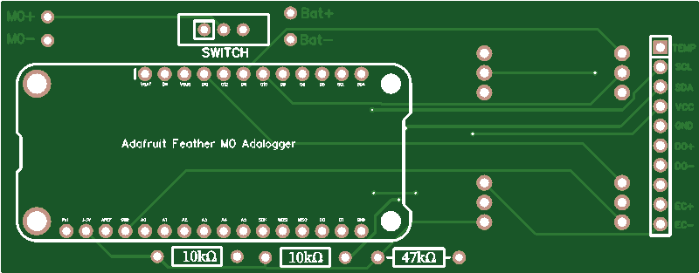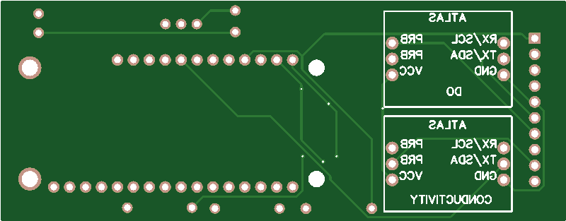

Figure 1. ctdTurbO2 circuit board. The top image will be called Side A, and the bottom image will be called Side B.

Step 1. Cut female header pins to segments of the following lengths: 1x 12 pins, 1x 16 pins, 4x 3 pins. Solder the 12 pin and 16 pin headers in the holes marked with red rectangles in Figure 1 such that the sockets are on Side A. Solder the 4 pin headers in the holes marked with red ovals in Figure 1 on Side B.

Step 2. Solder 10 kΩ and 47 kΩ resistors in their labeled spots marked in blue in Figure 1 such that the legs are exposed on Side B. Cut off the excess material.

Step 3. 2-pin JST connectors may have red and black on either side. Plug the male connector into the power port in the Adalogger. Check that the red wire is nearer the SD card slot, and the black wire nearer the Micro USB port. If so, proceed to Step 4. If not, unplug the connector, cut the wires close to the plug, and solder them back in opposite locations. Wrap the connections with electrical tape to prevent shorts. If necessary, swap the wires in the female connector and the battery following the same procedure.

Step 4. After checking the polarity of the JST connector, install the male plug by soldering the red wire to M0+ and the black wire to M0- on side A (marked in orange in Figure 1). Solder the red wire of the female plug to Bat+ and the black wire to Bat- on side A (marked in magenta in Figure 1).

Step 5. Install the slide switch on Side A in the location marked in blue in Figure 1.

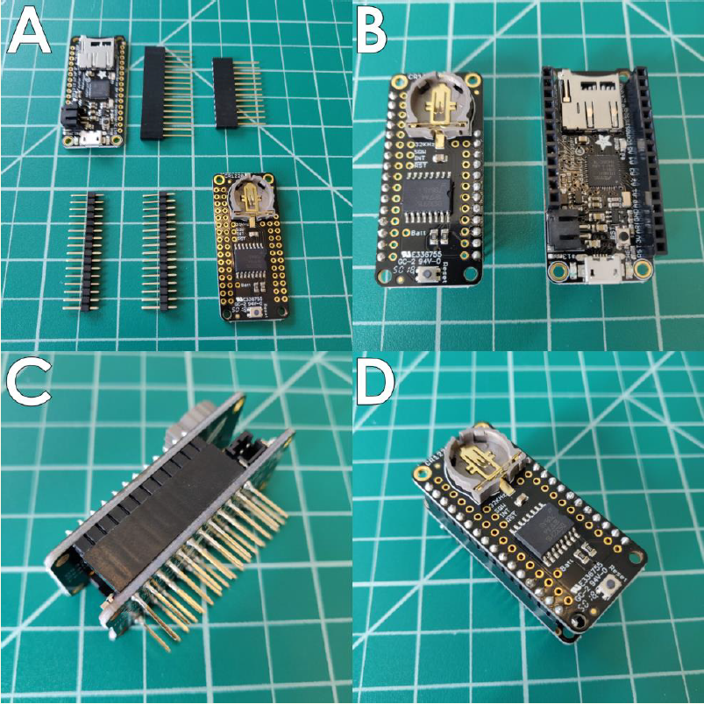

Figure 2. Connecting Adalogger and DS3231 using male and female header pins. A: Adalogger and DS3231 with associated headers. B: After soldering. C: Side view of connected components. D: Top view of connected components (Thaler, et al., n.d.).

Step 6. Solder female header pins to the Adalogger. Solder male header pins to the DS3231 Featherwing as in Figure 2.

Step 7. Insert pins on Adalogger into the headers on the PCB.

Step 8. Insert the Atlas conductivity and oxygen circuits in their marked locations on Side B.

Build the PVC Housing

Step 1. Use a PVC cutter to cut a 30 cm segment of pipe.

Step 2. Use a rotary tool with a cutting wheel to cut a large notch in one end of the pipe. It should be 4 cm deep along the length of the pipe and 7 cm wide around the circumference of the pipe. On the same end cut 3 evenly spaced notches, 4 cm deep and 1 cm wide around the circumference.

Prepare Probes for Casting in Epoxy

Step 1. Cut 2x 6 cm segments of wire in each of the following colors: red, black, blue, and green.

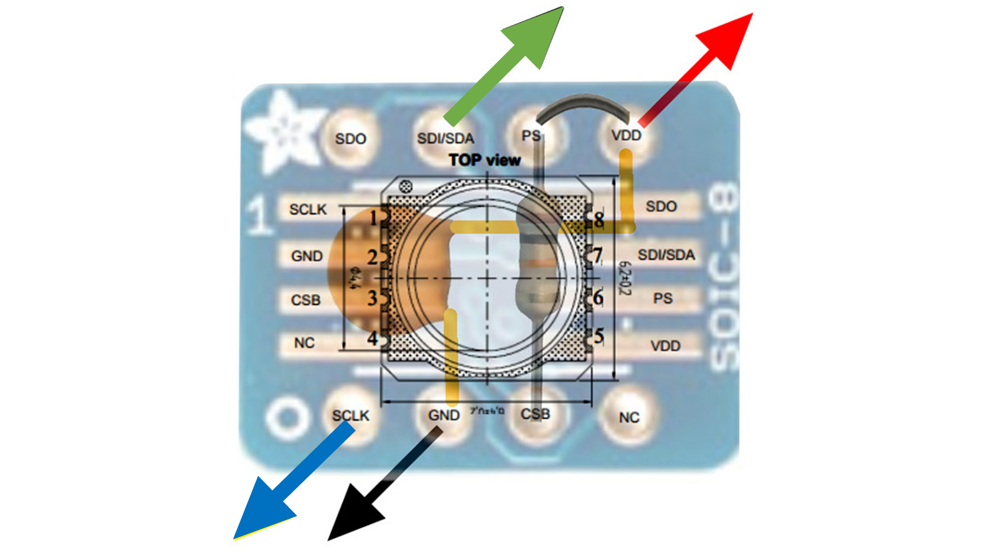

Figure 3. Diagram of pressure sensor chip and component alignment on SOIC-8 DIP adapter. Modified from (“Tutorial: Using an MS5803 Pressure Sensor with Arduino,” 2014).

Step 2. Solder the pressure sensor chip to the SOIC-8 to DIP adapter. Check that the dot on the pressure chip is lined up with Pin 1 on the adapter.

Step 3. On the back, insert a 10 kΩ resistor through the PS and CSB holes. Bend the legs to hold the resistor in place, but do not solder. Insert the 100 nF capacitor through the GND and VDD holes. Bend the legs and do not solder. Insert the wires in the holes on the backside of the SOIC-8 DIP adapter in the holes indicated in Figure 3. Solder everything together, while making a solder bridge between the PS and VDD holes. Cut the excess material off the legs of the resistor and capacitor.

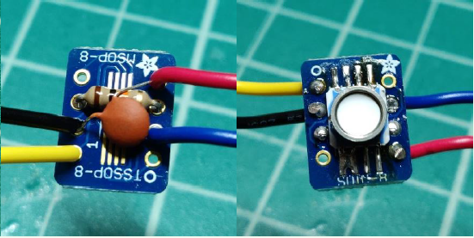

Figure 4. Finished pressure sensor. A: Back. B: Front. (Thaler, et al., n.d.).

Step 4. Solder the remaining black, red, green, and blue wires in the holes GND, VCC, SDA, and SCL holes on the back of the VCNL4010 (backscatter sensor).

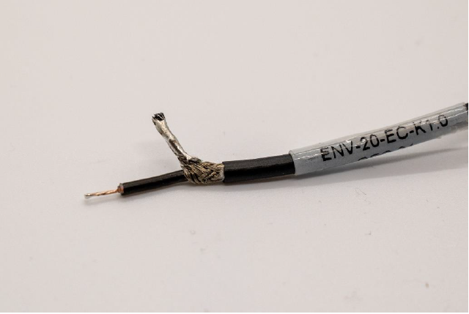

Figure 5. Conductivity and oxygen sensor leads. (Thaler, et al., n.d.).

Step 5. Cut the SMA connector off the conductivity sensor. Strip 2 cm of insulation off the cable. Carefully unravel the braided outer wire and twist together on one side as in Figure 5. Use solder to secure the twist. This will be the negative side of the probe, and the inner wire will be the positive. Repeat with the oxygen sensor.

3D Print and Cast the Endcap

Step 1. 3D print the endcap in black from the *openctdturbo v15.stl* file in the project GitHub.

Step 2. Use kimwipe and isopropyl alcohol to clean the glossy side of silicone mat and endcap. Place endcap face down on glossy side of mat and allow both to dry for 5 minutes.

Step 3. Measure out 6 g VViViD Scientific Epoxy (2 g EPX762 and 4 g EPX 128) per endcap in a paper cup. Stir mixture well with a popsicle stick. Apply heat with a heat gun to remove bubbles. Take care not to inhale fumes. Optional: extract bubbles by placing cup in a vacuum chamber.

Step 4. Use popsicle stick to apply epoxy mixture to the front of the pressure sensor board. Ensure that no epoxy touches the white gel membrane of the pressure sensor. Carefully insert pressure sensor into the pressure sensor hole in the endcap. Pour epoxy over pressure sensor board to fill well.

Step 5. Fill the backscatter sensor well in the endcap halfway with epoxy. Dip the backscatter sensor in epoxy and seat in the backscatter sensor well. Ensure that the view of the black emitter/receiver chip is unobstructed. Fill the well the rest of the way with epoxy. Hold wires up such that the backscatter sensor remains in place during curing.

Step 6. Allow the endcap to cure for 24 hours.

Step 7. Hold endcap using clamps or table vise such that pressure and backscatter sensors point horizontally. Insert conductivity sensor into endcap. Use hot glue on the backside (the part that will not be exposed to the environment) to hold the sensor securely in the endcap. Repeat with dissolved oxygen and temperature sensors.

Step 8. The wires for the backscatter and pressure sensors are not as long as those for conductivity, temperature, and oxygen. Splice red, black, blue, and green wire onto the existing leads so that they roughly equal in length to those for conductivity, temperature, and oxygen (~30 cm). Use heat shrink or electrical tape to prevent shorts. Twist and solder the ends of the blue (SCL) wires of the pressure and backscatter sensors together. Repeat with green (SDA). Twist and solder the ends of the red (VCC) wires of the pressure, backscatter, and temperature sensors together. Repeat with black (GND).

Step 9. Cover the backscatter and pressure sensors with electrical tape. Ensure that the tape does not actually touch the gel membrane of the pressure sensor.

Step 10. Apply PVC cement to the sides of the endcap and to the inside of the pipe on the side with the sensor guard. Line up the conductivity, temperature, and oxygen sensors so that they are protected by the sensor guard. Slide the endcap into the tube. If necessary, push the end cap in by tapping with a rubber mallet. Allow to cure for 24 hours.

Step 11. Stand the sensor with the sensors pointing down. Pull all the wires out and tape them to the outside of the pipe.

Step 12. Measure out 12 g VViViD Scientific Epoxy (4 g EPX762 and 8 g EPX 128) per ctdTurbO2 unit in a paper cup. Stir mixture well with a popsicle stick. Pour the entire mixture into the pipe, while taking care to minimize the amount of epoxy mixture that gets on the pipe wall or the wires. Allow to cure for 24 hours.

Step 13. Solder wires into their appropriately labeled holes on the board marked in black in Figure 1.